What makes a sound in your home?
Have a look around your home and make a note of things that make a noise. You can see one or two examples here to start you off! Use the table below to create your list and to write a sentence or two about why it is useful to hear that sound or what could go wrong if you can’t.
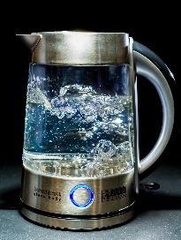
Once you have made your list, have a think what it might be like for a deaf person, who can’t hear those sounds. What could help them do you think? Have a chat with your family about it.
Item in your home | Why is it useful to hear it? What could go wrong if you can’t?
Kettle | Know when it has finished boiling water

