How members should acknowledge NBCRC in research publications

Use this affiliation for publications:
Nottingham Breast Cancer Research Centre, University of Nottingham, Biodiscovery Institute,
University Park, Nottingham, NG7 2RD

Tagging NBCRC to grant applications:
When creating a new grant application on RIS, NBCRC can be tagged under
“Create a project” and the under the heading “Research Centres/Groups”
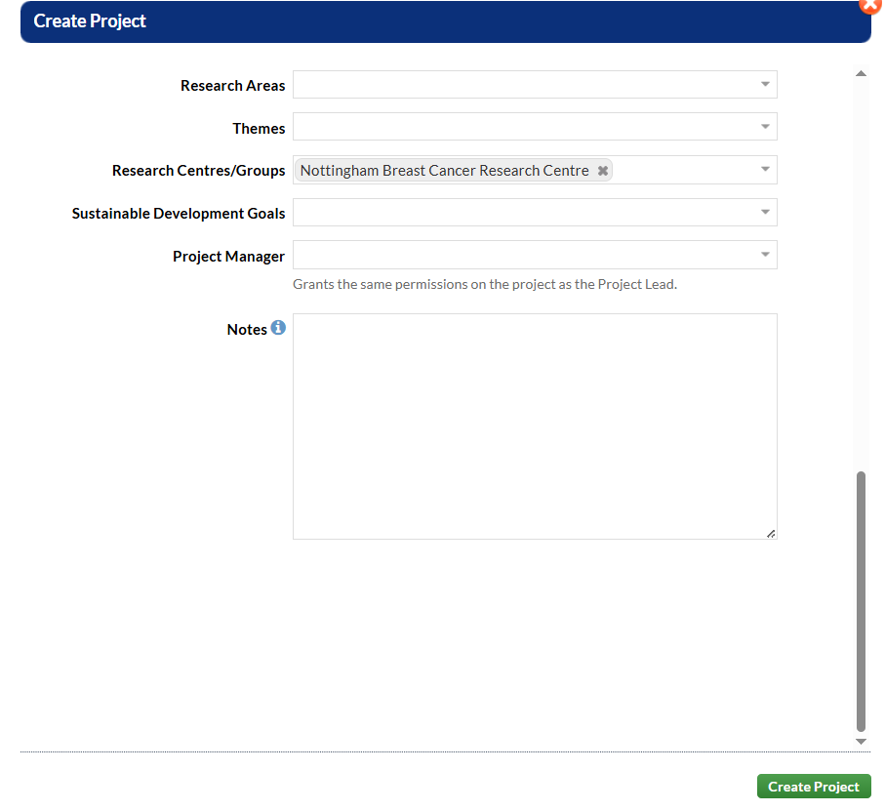
Email banner
Your name here
Your job title here

Department/School/Faculty
University of Nottingham
Room, Building
University Park
Nottingham, NGX XXX

+44 (0) 115 XX XXXXX | nottingham.ac.uk

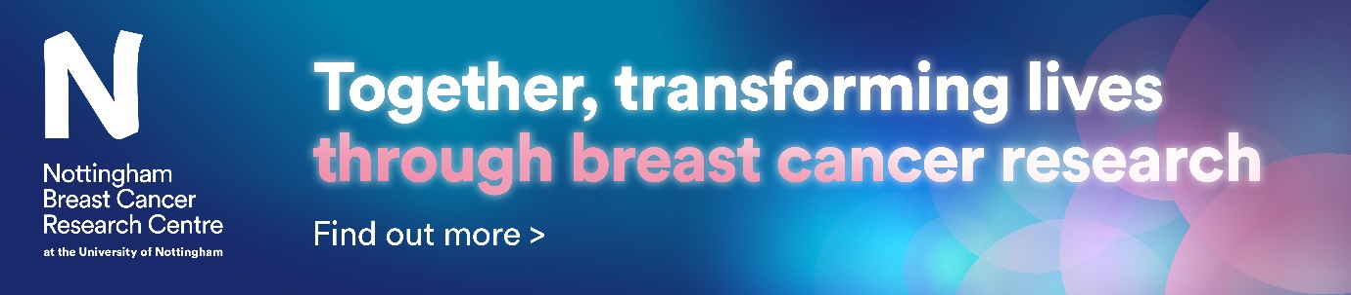

Follow us
Facebook.com/UniofNottingham
Twitter.com/UniofNottingham
Youtube.com/nottmuniversity
Instagram.com/uniofnottingham
Linkedin.com/company/university-of-nottingham
Foursquare.com/uniofnottingham

