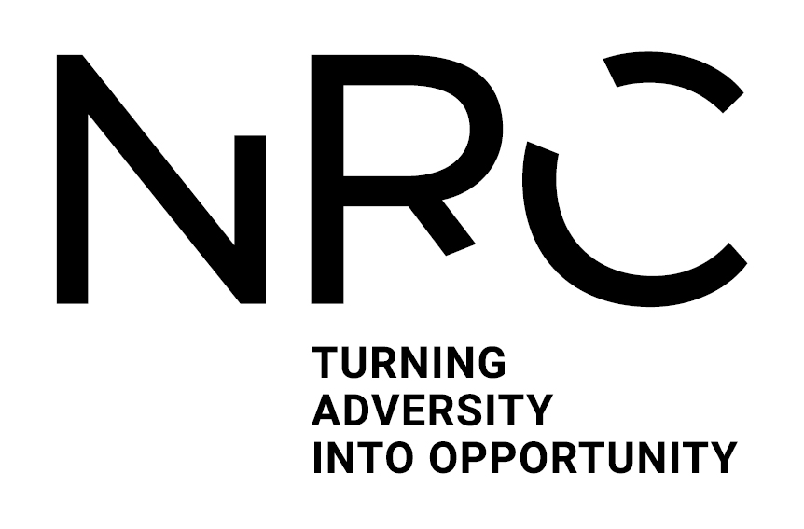

________________________________________________________________________________

Participant Information Sheet
(Final version 1.2 01 May 2024)
IRAS Project ID: 317661

Title of Study: How do Healthcare Professionals Recognise and Respond to Hospital-Acquired Deconditioning? (Modified Nominal Group)

Name of Chief Investigator: Professor Adam Gordon
Local Researcher(s): Meri Westlake, Dr Katie Robinson, Dr Alison Cowley, Public and Patient Involvement and Engagement (PPIE) representative

We would like to invite you to take part in our research study. Before you decide we would like you to understand why the research is being done and what it would involve for you. One of our team will go through the information sheet with you and answer any questions you have. Talk to others about the study if you wish. Ask us if there is anything that is not clear.

Study Snapshot
What is the purpose: The purpose of this study is to gain professional and lay stakeholder consensus on a draft conceptual framework of hospital-acquired deconditioning.

What is required of you: You will be asked review the draft framework before the nominal group. You will then be asked to attend a modified nominal group session with up to 10 other people to discuss, refine and aim to achieve consensus on the proposed framework.

How long: The review of the draft framework is expected to take approximately two hours at your own convenience. The modified nominal group is anticipated to take up to four hours.

Time and Location: 10th of July 2024, 1pm – 4pm at University of Nottingham Medical School, Room S/B1607, Queens Medical Centre, Lenton, Nottingham, NG7 2PU

Payments: There is no payment available for participating in this study at present. Light refreshments will be provided. Participants may be able to claim reimbursement for travel expenses up to £20.

Risks: It is anticipated that participation in this study will not expose you to major risks; however there may be a small risk of psychological or social distress from discussing your feedback and ideas on the topics and any conflict that may arise between participants.

What is the purpose of the study?
Hospital-acquired deconditioning occurs in nearly one in three adults over 65. Currently, it is unknown how frequently it occurs in adult populations. Hospital-acquired deconditioning is described in the literature as a new loss of independence in one or more basic activities of daily living that occurs independently of the expected impacts of the admitting illness or condition. However, this conceptualisation excludes many adults who may leave the hospital with an impaired capacity to engage in their previous lifestyle due to multiple factors.
While many interventions have been studied to prevent or treat hospital-acquired deconditioning, current evidence suggests that these interventions have limited effect. This is in part due to a lack of consensus on what hospital-acquired deconditioning is and subsequently how to measure its effects. It is currently unclear what healthcare professionals recognise and describe as hospital-acquired deconditioning. Furthermore, it is unclear what steps healthcare professionals take once hospital-acquired deconditioning has been recognised.
This study aims to achieve lay and professional stakeholder consensus on a draft conceptual framework of hospital-acquired deconditioning recognition and response. It is a part of a larger study to construct a conceptual framework of hospital-acquired deconditioning from which future interventions may be designed.
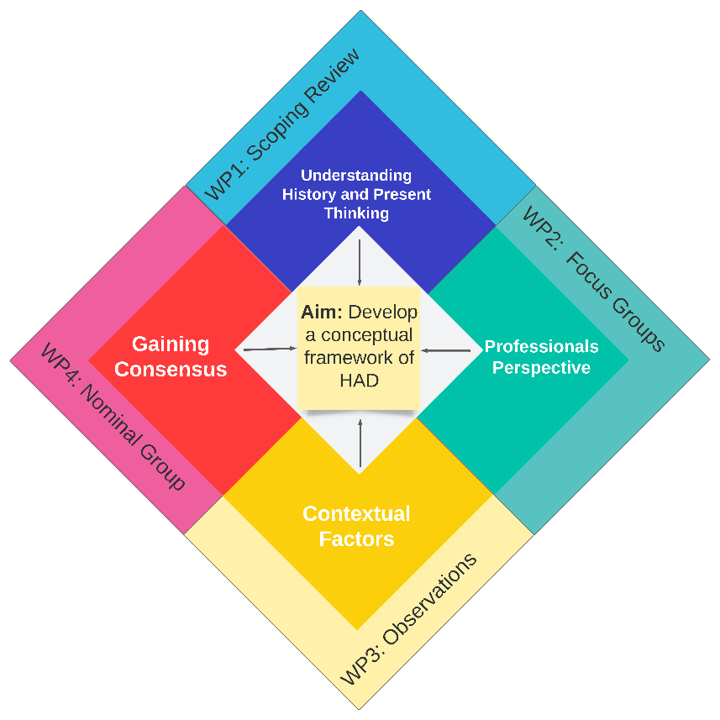

Why have I been invited?
You are being invited to take part because you are either:
- A registered healthcare professional with experience of working with adults with hospital-acquired deconditioning.
- A member of the public with experience of hospital-acquired deconditioning or a carer for someone with hospital-acquired deconditioning
- A funder or policy maker for rehabilitative or support services.

We are inviting up to 11 participants like you to take part.

Do I have to take part?
It is up to you to decide whether or not to take part. If you do decide to take part you will be given this information sheet to keep and be asked to sign a consent form online or on paper, whichever is your preference. If you decide to take part you are still free to withdraw at any time and without giving a reason. This would not affect your legal rights.

What will happen to me if I take part?
Before taking part, you will be asked to complete a consent form. Whilst our preference is to complete the consent on paper, an online option will be available. You will be given a copy of the consent form for your records. The study team will ask for this consent form before the group starts and basic personal information including your name, contact details (telephone and email), profession, and years of practice or relationship with hospital-acquired deconditioning.

The group will run as below
- Before the group – you will be sent a summary of findings from the conceptual framework, built from the previous three studies 3-5 working days before the event to have a look over it. It will likely take around two hours to review the draft framework and familiarise yourself with it. Don’t worry if you cannot do this; you will still be able to participate.

On the Day
Up to two rounds of the modified nominal group technique, each asking one question will be undertaken.
- Short introduction – the researcher will talk to you about the previous research leading up to this group and the studies that contributed to it (30 minutes)and the questions of the day.
- Silent generation – the researcher will ask you to generate ideas relevant to the question being proposed and ask you to write down any comments quietly. The researcher will give you some prompts as to what to consider.
- Refreshment break - 15 minutes
- –Round Robin– the researcher will ask each participant to give the group one idea at a time until all ideas have been heard. Other participants will be asked to record their comments and reflections silently when they are not speaking.
–
- Clarification/ Group discussion- you will be asked to talk freely with the group about the ideas put forward. The researcher won’t give their views, but they will lead the conversation toward central ideas relevant to each question. . At the end you will be asked to vote on the answers given. The researchers will use the group’s feedback to inform the content of the second round of the group.

The study team will collect any notes you have made for further analysis and refinement of the final framework.

Expenses and payments
Participants will not be paid an inconvenience allowance to participate in the study. Refreshments will be provided. You may be able to claim reimbursement for travel expenses up to £20

What are the possible disadvantages and risks of taking part?
The study team does not anticipate any significant risks to you should you decide to participate. However, there may be a small risk of psychological or social distress from being asked to discuss your views on the framework in a group setting with a mixed population. This study will take up to eight hours face to face and two hours of your own time.
It is hoped that the benefit of being able to discuss your experiences and have those contribute to improving future prevention and treatment for hospital-acquired deconditioning will offset this inconvenience.
In the event of significant distress, signposting to local support services will be given as well as the opportunity to discuss the group content one-to-one with a member of the study team to debrief.

What are the possible benefits of taking part?
We cannot promise the study will help you, but the information we get from this study may help inform future interventions for preventing or treating hospital-acquired deconditioning.

What happens when the research study stops?
You will be asked for your contact details if you would like to receive a summary of the results from the modified nominal group technique.

What if there is a problem?
If you have a concern about any aspect of this study, you should ask to speak to the researchers who will do their best to answer your questions. The researchers’ contact details are given at the end of this information sheet. If you remain unhappy and wish to complain formally, you should then contact:
Head of Division- Rehabilitation and Ageing
Professor Neil Coulson
Email: lwznsc@exmail.nottingham.ac.uk
Patients and Carers: Patients affected by this work are asked to formally complain to the hospital patient advisor and liaison service (PALS). At Nottingham University Hospitals NHS Trust the PALS team can be contacted on: 0800 183 0204 or email: PALS@nuh.nhs.uk

In the event that something does go wrong and you are harmed during the research and this is due to someone's negligence then you may have grounds for a legal action for compensation against the University of Nottingham but you may have to pay your legal costs.

Although what you say to us is confidential, should you disclose anything to us which we feel puts you or anyone else at any risk, we may feel it necessary to report this to the appropriate persons. Every attempt will be made to seek your consent for this to occur however it may be necessary in the interests of safeguarding patients, yourself or others to communicate with the appropriate persons.

Will my taking part in the study be kept confidential?
We will follow ethical and legal practice and all information about you will be handled in confidence.

If you join the study, we will use information collected from you during the course of the research. This information will be kept strictly confidential, stored in a secure and locked office, and on a password protected database at the University of Nottingham. Under UK Data Protection laws the University is the Data Controller (legally responsible for the data security) and the Chief Investigator of this study (Professor Adam Gordon) is the Data Custodian (manages access to the data). This means we are responsible for looking after your information and using it properly. Your rights to access, change or move your information are limited as we need to manage your information in specific ways to comply with certain laws and for the research to be reliable and accurate. To safeguard your rights we will use the minimum personally – identifiable information possible.

You can find out more about how we use your information and to read our privacy notice at:

https://www.nottingham.ac.uk/utilities/privacy.aspx.

The data collected for the study will be looked at and stored by authorised persons from the University of Nottingham who are organising the research. They may also be looked at by authorised people from regulatory organisations to check that the study is being carried out correctly. All will have a duty of confidentiality to you as a research participant and we will do our best to meet this duty.

Where possible information about you which leaves the University Of Nottingham site will have your name and address removed and a unique code will be used so that you cannot be recognised from it.

Your contact information will be kept by the University of Nottingham for 12 months after the end of the study so that we are able to contact you about the findings of the study and possible follow-up studies (unless you advise us that you do not wish to be contacted). This information will be kept separately from the research data collected and only those who need to will have access to it. All other data (research data) will be kept securely for 7 years. After this time your data will be disposed of securely. During this time all precautions will be taken by all those involved to maintain your confidentiality, only members of the research team given permission by the data custodian will have access to your personal data.

In accordance with the University of Nottingham’s, the Government’s and our funders’ policies we may share our research data with researchers in other Universities and organisations, including those in other countries, for research in health and social care. Sharing research data is important to allow peer scrutiny, re-use (and therefore avoiding duplication of research) and to understand the bigger picture in particular areas of research. Data sharing in this way is usually anonymised (so that you could not be identified) but if we need to share identifiable information we will seek your consent for this and ensure it is secure. You will be made aware then if the data is to be shared with countries whose data protection laws differ to those of the UK and how we will protect your confidentiality.

Although what you say to us is confidential, should you disclose anything to us which we feel puts you or anyone else at any risk, we may feel it necessary to report this to the appropriate persons. Every attempt will be made to seek your consent for this to occur however it may be necessary in the interests of safeguarding patients, yourself or others to communicate with the appropriate persons.

What will happen if I don’t want to carry on with the study?

Your participation is voluntary and you are free to withdraw your consent at any time, without giving any reason, and without your legal rights being affected. If you withdraw we will no longer collect any information about you or from you but we will keep the information about you that we have already obtained as we are not allowed to tamper with study records and this information may have already been used in some analyses and may still be used in the final study analyses. To safeguard your rights, we will use the minimum personally-identifiable information possible.

What will happen to the results of the research study?

The results of this study will be written up primarily for Meri Westlake’s PhD thesis however, results will also be written up for peer-reviewed publication. Further avenues for dissemination include local and international academic conferences, presentations to, PPIE groups, relevant communities of practice and special interest groups. You can indicate if you would like a copy of the results of the modified nominal group sent to you on your consent form and by providing your email.

Any direct quotes from your participation will be used with pseudo-anonymised identification which will contain your practice discipline or relationship to hospital-acquired deconditioning and no further information.

Who is organising and funding the research?
This research is being organised by the University of Nottingham and is being funded by the National Rehabilitation Centre.

Who has reviewed the study?
All research in healthcare is looked at by independent group of people, called a Research Ethics Committee, to protect your interests. This study has been reviewed and given favourable opinion by Cambridge Central Proportional Review Research Ethics Committee.

Further information and contact details
Chief investigator: Professor Adam Gordon,
Professor of the Care of Older People
Phone: 0113724668
Email: adam.gordon@nottingham.ac.uk

Co-investigators: Dr Alison Cowley
Associate Chief AHP Research and Innovation
Email: Alison.cowley@nottingham.ac.uk; Alison.cowley@nuh.nhs.uk

Dr Katie Robinson
Senior Research Fellow Email: katie.robinson@nottingham.ac.uk

Mx Meri Westlake
PhD Candidate
Email: Meri.westlake1@nottingham.ac.uk

Study Coordinating Centre: Centre for Rehabilitation and Ageing
Academic Unit 3 – Injury, Recovery and Inflammation Sciences
Queens Medical Centre
University of Nottingham

