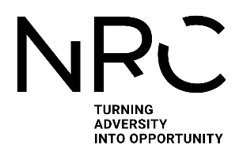

**Does Hospital-Acquired Deconditioning (HAD) affect you?**

We are seeking people affected by HAD and professionals to shape our understanding of HAD

HAD Consensus meri.westlake1@ nottingham.ac.uk

Phone number

HAD Consensus meri.westlake1@ nottingham.ac.uk

Phone number

HAD Consensus meri.westlake1@ nottingham.ac.uk

Phone number

HAD Consensus meri.westlake1@ nottingham.ac.uk

Phone number

HAD Consensus meri.westlake1@ nottingham.ac.uk

Phone number

HAD Consensus meri.westlake1@ nottingham.ac.uk

Phone number

HAD Consensus meri.westlake1@ nottingham.ac.uk

Phone number

HAD Consensus meri.westlake1@ nottingham.ac.uk

Phone number

HAD Consensus meri.westlake1@ nottingham.ac.uk

Phone number

HAD Consensus meri.westlake1@ nottingham.ac.uk

Phone number

**Consensus on Hospital-Acquired Deconditioning**

Hospital acquired deconditioning (HAD) is reported in the literature as a new loss of ability in activities such as walking, eating or dressing. This loss is associated with being in hospital rather than due to the person’s injury or illness. This description leaves out many adults and may not reflect how HAD is used in the hospitals.

This study aims to achieve public and professional consensus on a draft model of hospital-acquired deconditioning recognition and response. The model is newly developed from three previous studies as the diagram shows.

We would like to hear your views  
and level of agreement on a   
newly proposed framework  
which may inform future  
care for HAD.

Participants will receive:

* Refreshments
* Travel expenses up to £20



**Scan the QR code or visit** [**https://www.nottingham.ac.uk/mhs/research/nrc-ncap/phd-research.aspx**](https://www.nottingham.ac.uk/mhs/research/nrc-ncap/phd-research.aspx) **for more info**

**.**

**Location**

* In – person consensus group hosted at the University of Nottingham
* 10th July 2024 from 1pm to 5pm
* Approximately 4 hours in duration (plus two hours of your own time before the group)

**Are you eligible?**

* A health or social care professional working with adults affected by HAD
* Experience with Hospital-Acquired Deconditioning as a patient or a close supporter of someone with HAD
* A policy maker within the NHS or Social care with an interest in HAD

**If you’re unsure if you meet the requirements, email a member of the study team:**

* Meri Westlake (BHSc, GradDipArts)
* PhD Candidate
* Meri.westlake1@nottingham.ac.uk

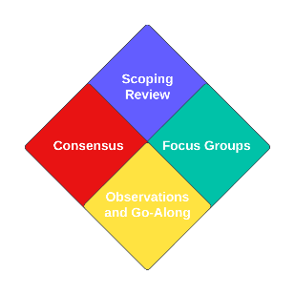

Hospital Acquired Deconditioning: Recognition and Response. Modified Nominal Group Poster V1.1 01.05.2024.1 IRAS: 317761 UoN: 22039