First Aid
Building Name
First Aiders
Name |  |  |  |  | Room |  | Ext
Name |  |  |  |  | Room |  | Ext
Name |  |  |  |  | Room |  | Ext
Name |  |  |  |  | Room |  | Ext
Name |  |  |  |  | Room |  | Ext
Name |  |  |  |  | Room |  | Ext
Nearest First Aid Box
Nearest AED/Defib
Useable by any person, the unit will instruct you
 |  |  | Security mobile units – 8888 or 0115 951 8888
IN AN EMERGENCY TELEPHONE EXT. 8888 (0115 951 8888)
- If immediate medical attention is required, phone Trent Security for an ambulance on 8888 or 0115 951 8888
- Security staff are trained in First Aid; phone 13013 or 0115 951 3013 if none of above available
- If the condition requires further treatment, refer the casualty to Accident & Emergency at the Queens Medical Centre

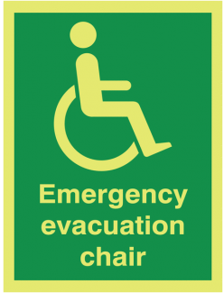
EVAC CHAIRS
Located:

Trained  Operators |  |  |  | Room |  |  | Ext

