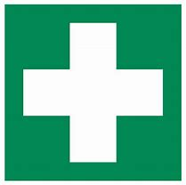

Laser Radiation Exposure Emergencies

Actual or suspected Eye Injury
In case of actual or suspected laser radiation exposure to the eye, contact Eye Casualty at the Queens Medical Centre
07:00 – 22:00hrs Tel. 0115 9249924 ext 62882
(Eye Casualty is located on EENT Centre, A floor QMC)

22:00 – 07:00hrs Tel. External 999 or 1111
0115 9518888 (UoN Security)

Laser information for medical practitioners
Laser Type

Class / power involved

Wavelength involved

Location of the above laser(s) (building/lab number)

Skin Burns
Skin burns, i.e. thermal burns, can be treated in the same way as other burns. A local First Aider should be contacted in line with local procedures.

Inform local contact
Inform the following as soon as possible that an incident has occurred. (Ensure the injured person is helped first)
Name: | Tel:
Incident reporting
Any suspected or confirmed injuries should be reported on the University’s incident reporting system (irs@nottingham.ac.uk). In addition to actual injury incidents, near misses should also be reported.

