Guide Notes on the use of Calculators in Exams – Academic Year 2019-2020
The rubrics relating to calculator use in examinations have been changed for the academic year 2019-2020. The intention is that, in future, we will explicitly specify the models of calculator that are allowed. However, in order to be fair to existing students we have made interim arrangements that will apply to students taking modules at level 2 and above.

CALCULATOR RUBRICS

Standard rubrics (updated October 2018)
- No calculators are permitted in this examination
- Only a calculator from approved list A may be used in this examination.

List A
Basic Models  Aurora HC133  Casio HS-5D  Deli – DL1654  Sharp EL-233 | Scientific Calculators  Aurora AX-582  Casio FX82 family  Casio FX83 family  Casio FX85 family  Casio FX350 family  Casio FX570 family  Casio FX 991 family  Sharp EL-531 family  Texas Instruments TI-30 family  Texas BA II+ family
- Only a calculator from approved list B may be used in this examination.

List B
Basic Models  Aurora HC133  Casio HS-5D  Deli – DL1654  Sharp EL-233 | Scientific Calculators  Aurora AX-582  Casio FX82 family  Casio FX83 family  Casio FX85 family  Casio FX350 family  Casio FX570 family  Casio FX 991 family  Sharp EL-531 family  Texas Instruments TI-30 family  Texas BA II+ family | Graphical Calculators  Casio FX9750 family  Texas Instruments TI82 family

Interim Arrangements
During the interim periods, specified below, invigilators will allow calculators functionally equivalent to those on the lists provided that the make & model are entered onto the cover of all answer booklets.
Academic Year | Level 1 | Level 2 | Level 3 | Level 4
2019/20 | Standard Only | Interim | Interim | Interim
2020/21 | Standard Only | Standard Only | Interim | Interim

Guidelines
- Candidates may use an electronic calculator in module examinations, provided it is one of the models specified by the rubric and has not been modified in any way. Devices with facilities for storing and retrieving text, personal organisers, dictionaries, thesauruses, language translators and computers, and other devices capable of communicating directly with other similar devices are not permitted in examinations. Exceptionally students registered as dyslexic may use specified electronic dictionaries, if they have been assessed by the University as requiring them.

- The use of an inappropriate calculator will be considered as misconduct. Visual checks to ensure that calculators are on the relevant approved list will be undertaken by the invigilators during the examination.

The exact models included in the lists will be reviewed annually so the lists given here apply specifically to the current academic year.

Types of Calculator
We’ve roughly divided calculators into 4 types:
- Basic 4- function models;
- Standard scientific calculators;
- Graphical scientific calculators;
- Advanced (CAS-enabled) models.

List A only contains basic 4-function and standard scientific models, List B also includes graphical scientific models. Advanced (CAS-enabled) models are not allowed in any examinations. Under the interim arrangements we are principally concerned with ensuring that students do not have unpermitted models rather than exactly which model they do have.

Basic 4-function Models (All equivalent to models on list A or list B)
These are models with rather few buttons and simple rectangular displays (these used to be referred to as “single-line display models”). The buttons are basically just digits 0-9, +-×÷%±√=, C & CE and perhaps a few memory buttons (M, M+, MR, MD).
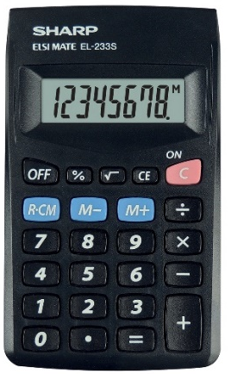
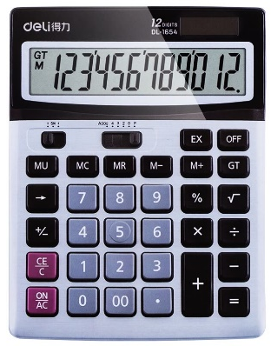
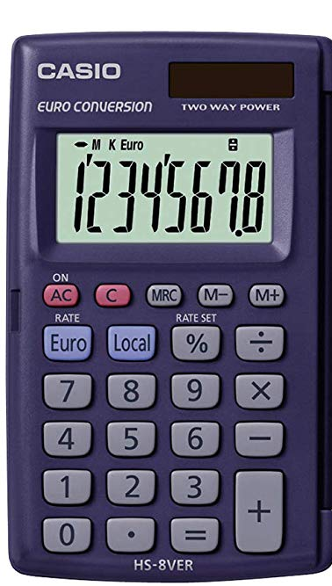
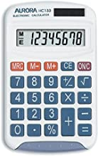
All such basic models are essentially equivalent and we would not want invigilators to be querying students use of them because they are not the specified model, even under the new rubrics (unless calculators are not allowed at all).

Standard Scientific Models (Equivalent to models on List A or List B)
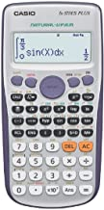
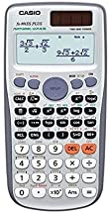
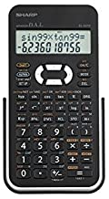
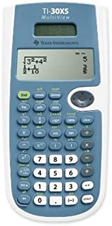
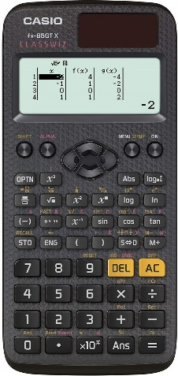
These have more buttons to allow access to a wide range of mathematical functions as well as more sophisticated controls for changing notation and rolling back steps in a calculations. They also have rectangular displays but frequently display more than a single line. All such models can be regarded as equivalent to those on lists A or B as long as they are not one of the excluded advanced models.

Graphical Scientific Models (Equivalent to models on List B only)
These have similar keypad arrangements to standard scientific models (possibly with even more buttons) but have larger display screens (some almost square in shape) which allow limited plotting of graphs.
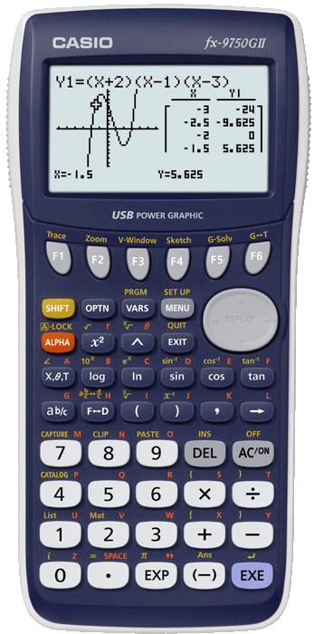
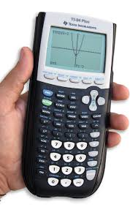
Any of these are equivalent to the graphical models on list B but are not permitted for list A.

Advanced (CAS-enabled) Models (Not allowed at all)
These are more expensive models which have a lot of functionality, including basic computer algebra systems (CAS), so these are not allowed in any examination. Unfortunately it is not always straightforward to identify these visually (although any calculator with a full alphabetic keyboard is not permitted) so we will list the models that we know of that are not permitted in any exam:

Prohibited Models

TI Nspire CX II CAS
TI-89 family
TI-92 family
TI- Voyage 2000 family
HP-50 family
HP – Prime family
Casio fx- CG500 family
Casio Class-Pad family

