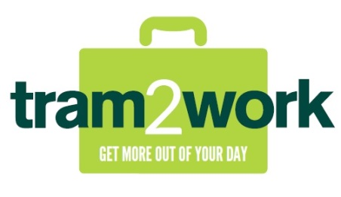
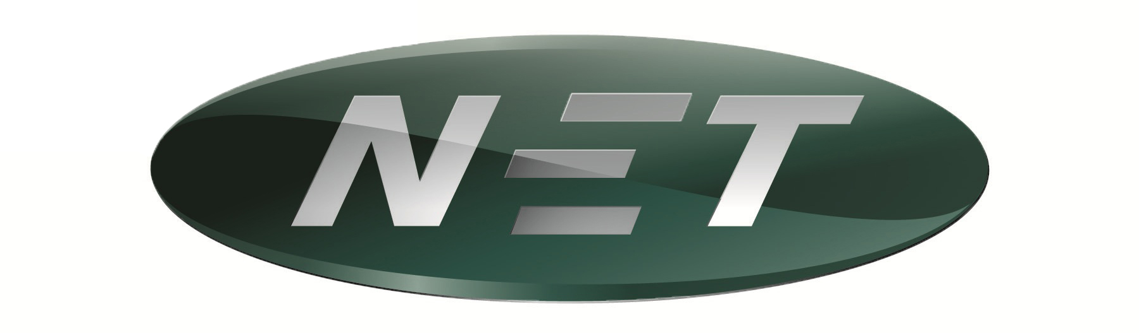

Payment of travel pass fees by salary deduction – NET

Please complete this form clearly, using BLOCK CAPITALS.

Full name:

Home address:

Postcode:
Phone number:

Email:

Payroll number:

Library card number:
(shown on University card)
School/Department:

Student card / NUS extra number:
(if applying for student pass)

I wish to purchase the following travel pass (please indicate below):
Travel pass | Total cost | Monthly deduction | Tick  (one only)
Annual tram2work adult | £440.00 | £36.66 | ❒
Annual tram2work student | £265.00 | £22.08 | ❒

I wish to commit to the travel pass scheme for 12 months, commencing 01 / MM / YYYY, and give permission for the cost of my travel pass to be deducted from my salary at the University of Nottingham.

Please deduct the amount of £…………….. each month for 12 consecutive months.

I understand that, if I leave the University during the 12 months, I must notify Pension and Benefits Services of my leaving date. I give permission for the outstanding balance to be deducted from my final month’s salary if I have not agreed alternative arrangements with Pension and Benefits Services.

I understand that, at the end of the 12 month period, my travel pass will cease to be valid and that it is my responsibility to re-apply to the scheme to arrange a new pass.

Signed: ……………………………………………………….. Date: ………………………………………………………..

Please email this form to: benefits@nottingham.ac.uk
Or post to: Pension & Benefits Services, Financial Operations, University of Nottingham, King’s Meadow Campus, Lenton Lane, Nottingham, NG7 2NR

